# **Programming with Python**

# Module 10:



* Other Dev Environments
* Other Languages
* GetHub

In this class we have used Python to learn the foundations of programing. In this module I want to extend that knowledge to other technologies in an effort to show you how these basic concepts can be applied.

As your programs become more complex you may need to add more people or use different technologies to complete your projects. This often entails the use of technologies and tools outside of what you presently know.

# Other Dev Environments

Microsoft has long used Visual Studio as its development environment. Recently this environment is being moved to an Open Source version in addition to its free version called Community Edition.

The Open Source version is called Visual Studio Code (beta) and can be installed on Mac and Linux.

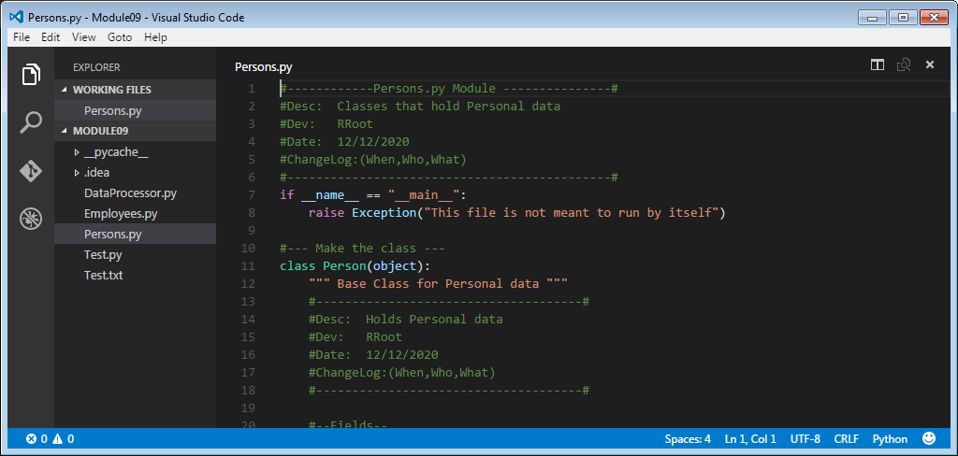

The Community Edition is currently only running on Windows, but will be available in the future on Mac and Linux in the future.

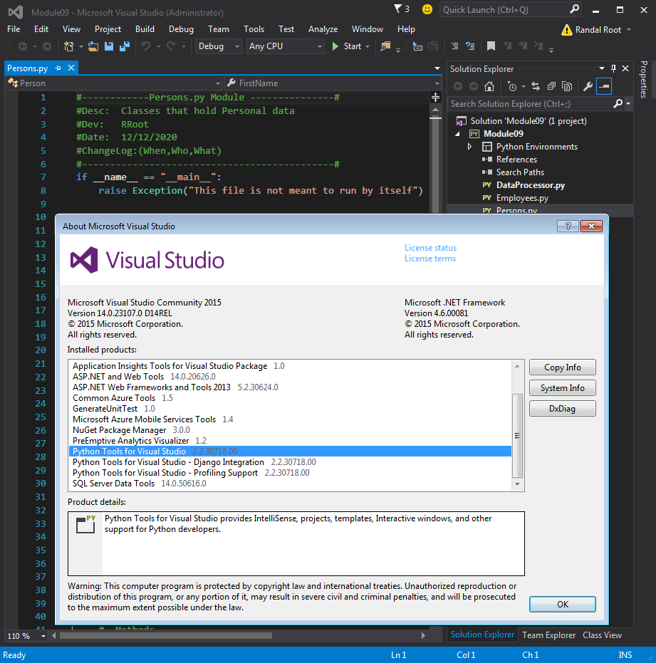

# Other Languages

Once you have learned one language you will find that learning another is often quite easy.

For example, compare the difference between a Python Script file and C# code file. Here is an example of a python class

#### Python

#--- Make the class ---

class Person(object):

""" Base Class for Personal data """

#--Fields--

__Counter = 0

#--Constructor--

def __init__(self, FirstName = ""):

#Attributes

self.__FirstName = FirstName # Private Attribute

Person.__SetObjectCount() # Private Method

#--Properties--

#FirstName

@property #getter(accessor)

def FirstName(self):

return self.__FirstName

@FirstName.setter #(mutator)

def FirstName(self, Value):

self.__FirstName = Value

#--Methods--

def ToString(self):

"""Explictly returns field data"""

return self.FirstName

def __str__(self):

"""Implictly returns field data"""

return self.FirstName

@staticmethod

def GetObjectCount(): # You do not need the self keyword

return Person.__Counter

@staticmethod

def __SetObjectCount(): # This is a private and static method

Person.__Counter += 1

#--End of class Person--

#### Now let’s compare it to Microsoft’s C# language (which is very similar to Java!).

#### Microsoft’s C#

class Person

{

//--Fields--

static int __Counter = 0;

string __FirstName;

//--Constructor--

public Person(string FirstName = "")

{

//Attributes

this.__FirstName = FirstName; // Private Attribute = Field in C#

Person.__SetObjectCount(); // Private Static Method

}

//--Properties--

//FirstName

public string FirstName

{

get

{ return __FirstName; }

set

{ __FirstName = value; }

}

public override string ToString()

{

return this.FirstName;

}

static int GetObjectCount()

{ // You do not need the self keyword

return Person.__Counter;

}

static void __SetObjectCount()

{ // This is a private and static method

Person.__Counter += 1;

}

}//--End of class Person--

## Demonstration

Your instructor will now demonstrate another comparison between Python and C# using a Visual Studio Solution.

# GetHub

GetHub is a popular choice for managing your code files. This technology provides a simple way to track changes to your files and allow multiple people to work on the same files at once.

To use GetHub you to create an account on their web page.

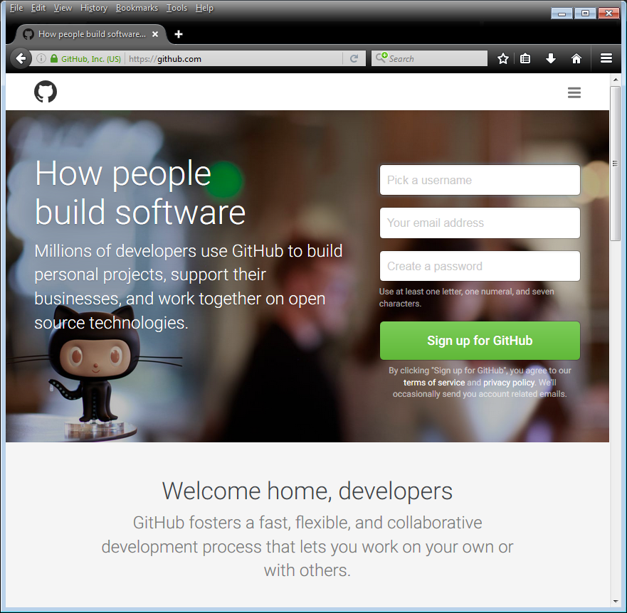

Once you have a GetHub account, you need to sign-in.

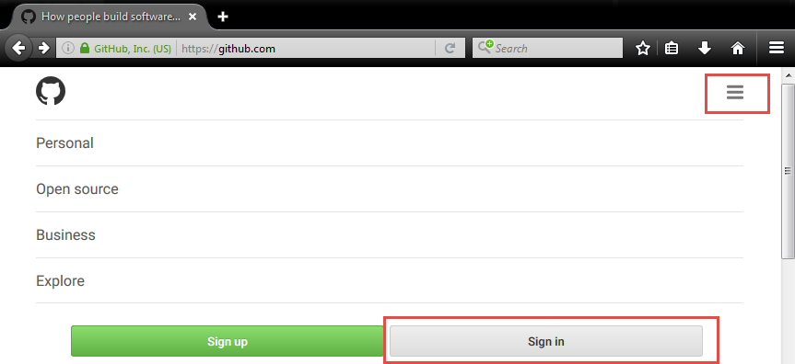

You will next create a new Repository.

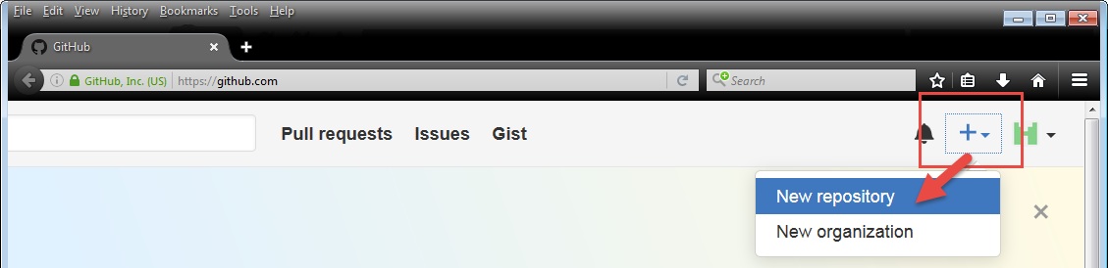

You will be sent to a new screen where you can

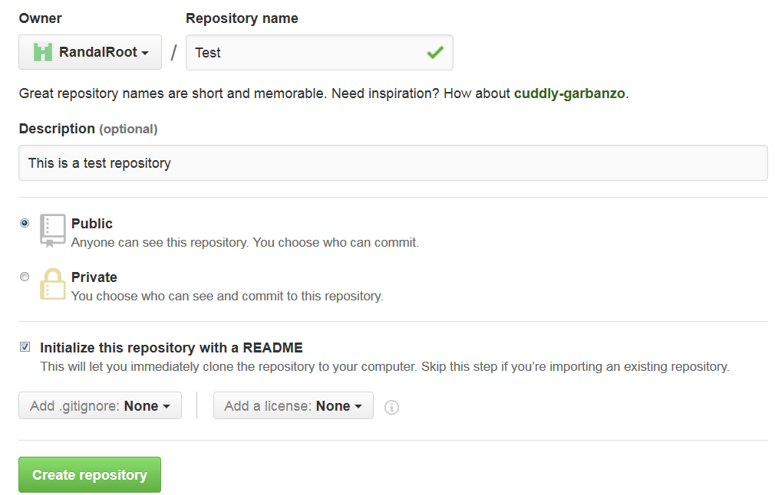

At this point you will be taken to a dashboard where you can manage your Repository. For instance, we will start by uploading some python script files.

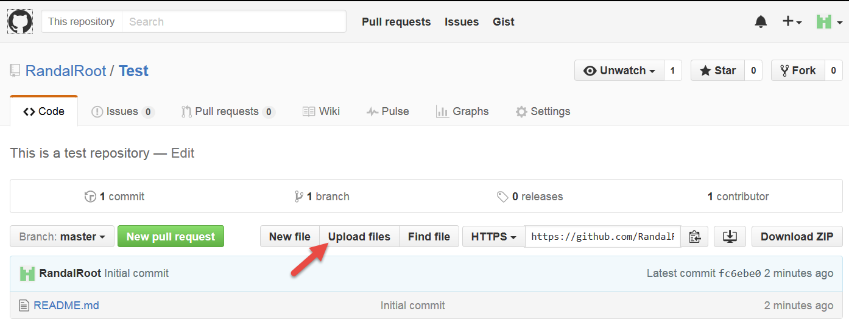

After clicking the Upload Files button, we choose the files we wish to upload.

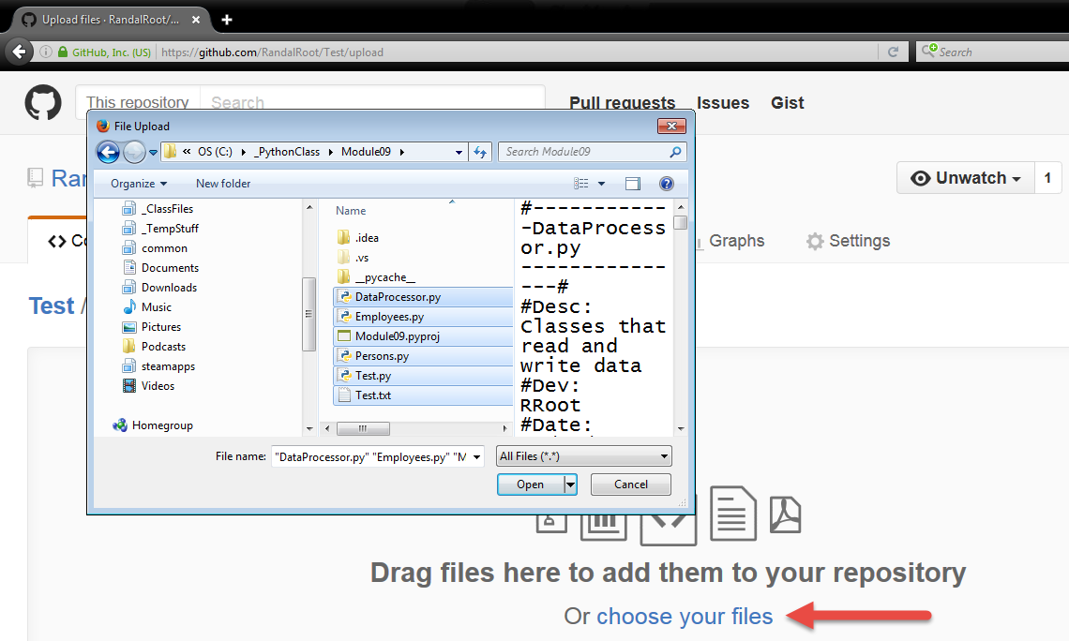

And then verify and add notes about the upload.

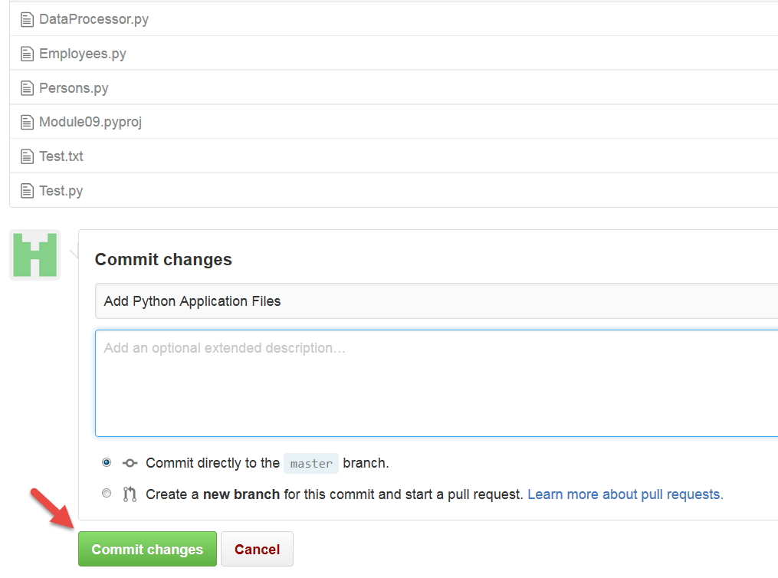

These files are now part of the Original “Master Branch” of the Repository. To make changes to the files later we would create a new working Repository Branch and modify the code in that branch.

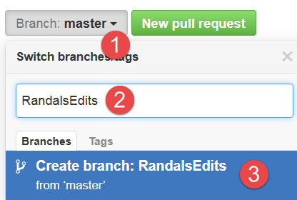

I can now click on a file and make changes directly on GetHub or upload a changed version of the file. Let’s make a direct change as an example.

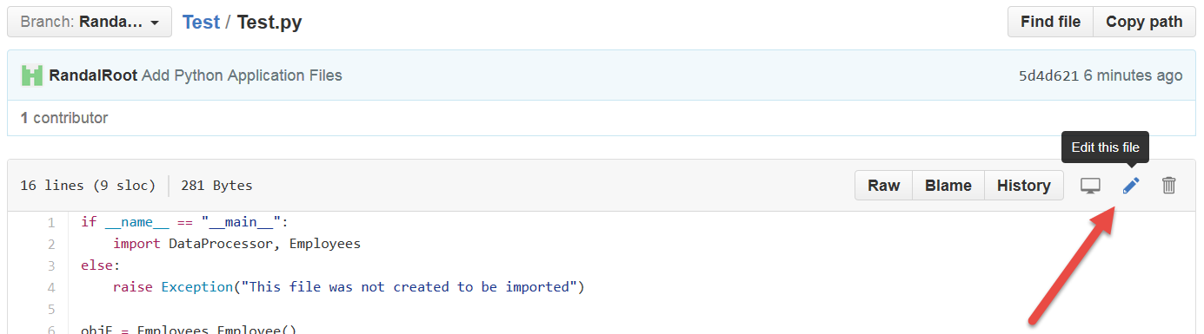

We will keep is simple and just add a couple of comments and remove some blank lines.

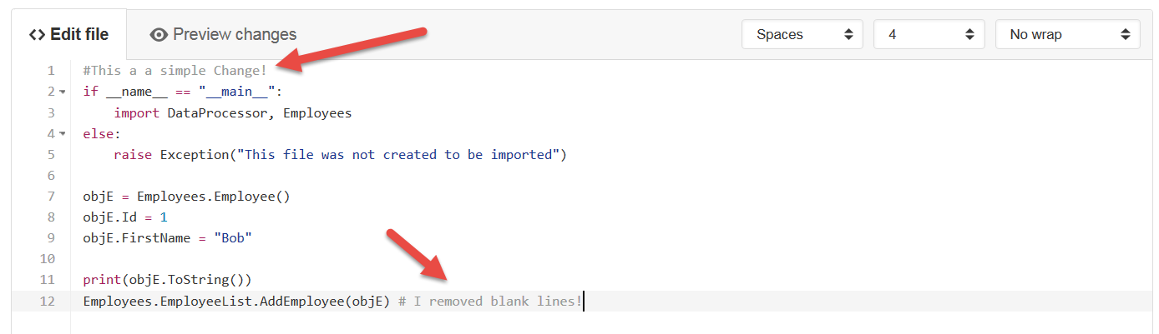

Now we must commit the change before it will be saved!

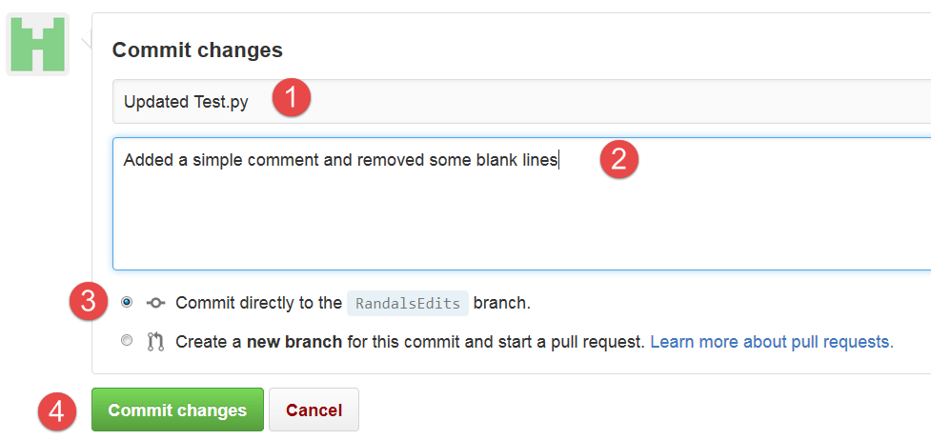

Going back to the Test branch’s dashboard, we can now compare the changed version to the original, using the “New pull request” button.

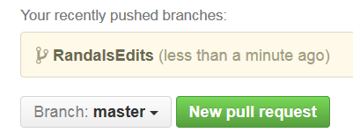

Now you add some information about why you want to merge your new file with the original Master’s version of the file. Clicking the Create pull request will submit the request to the GetHub server.

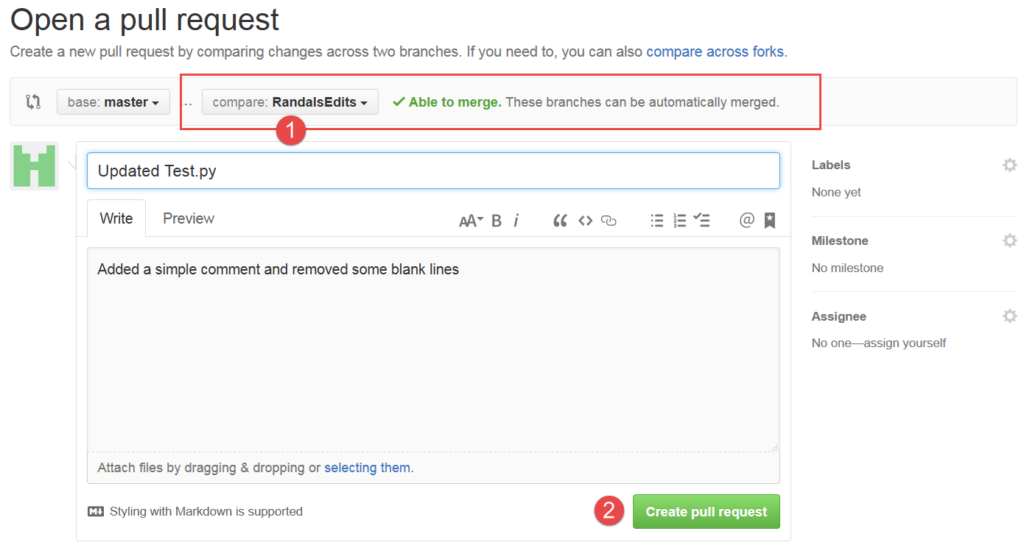

Once a request is submitted, you will see it on the dashboard. Clicking the Open button allows you (or anyone managing or working with you) the ability to review the changes made to the file in comparison the original.

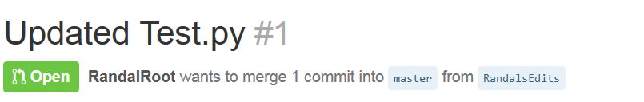

Since one request can have many files, you will also have to click on the individual file you want to review.

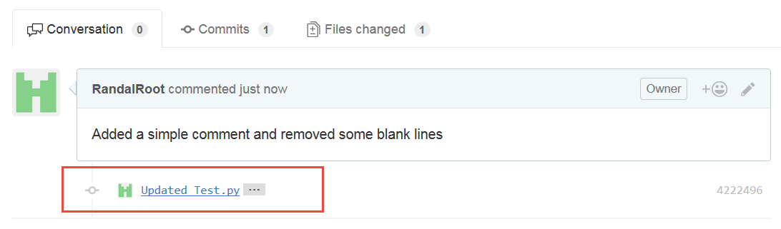

Once a file is selected you will see the differences indicated with a + for added text and a – for subtracted text.

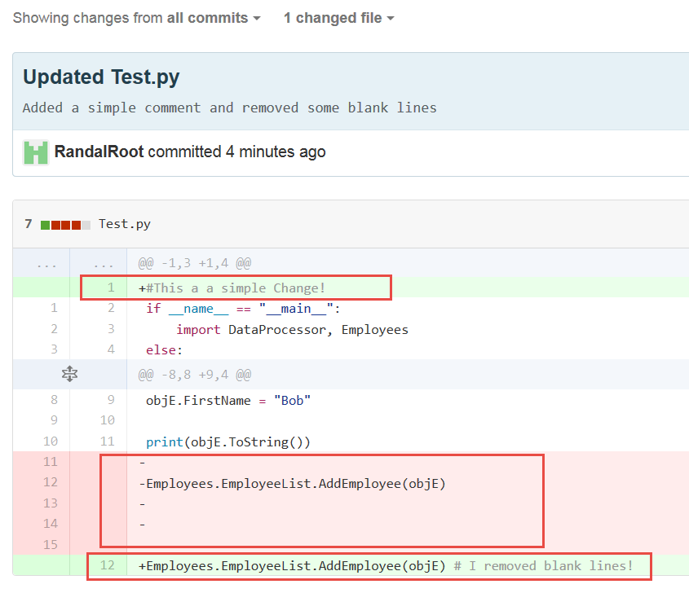

Now go back to the “Pull requests” tab and click in the request you want to work with.

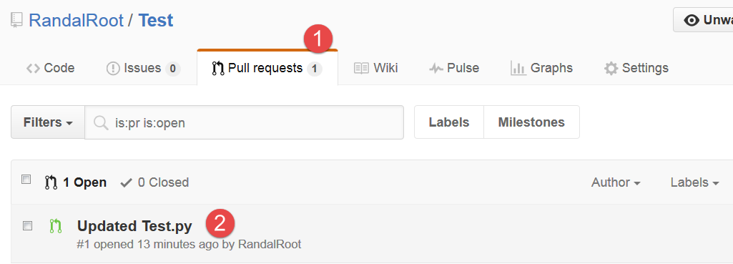

Finally, you will be able to click the “Merge pull request” button to merge your changes with the Master version.

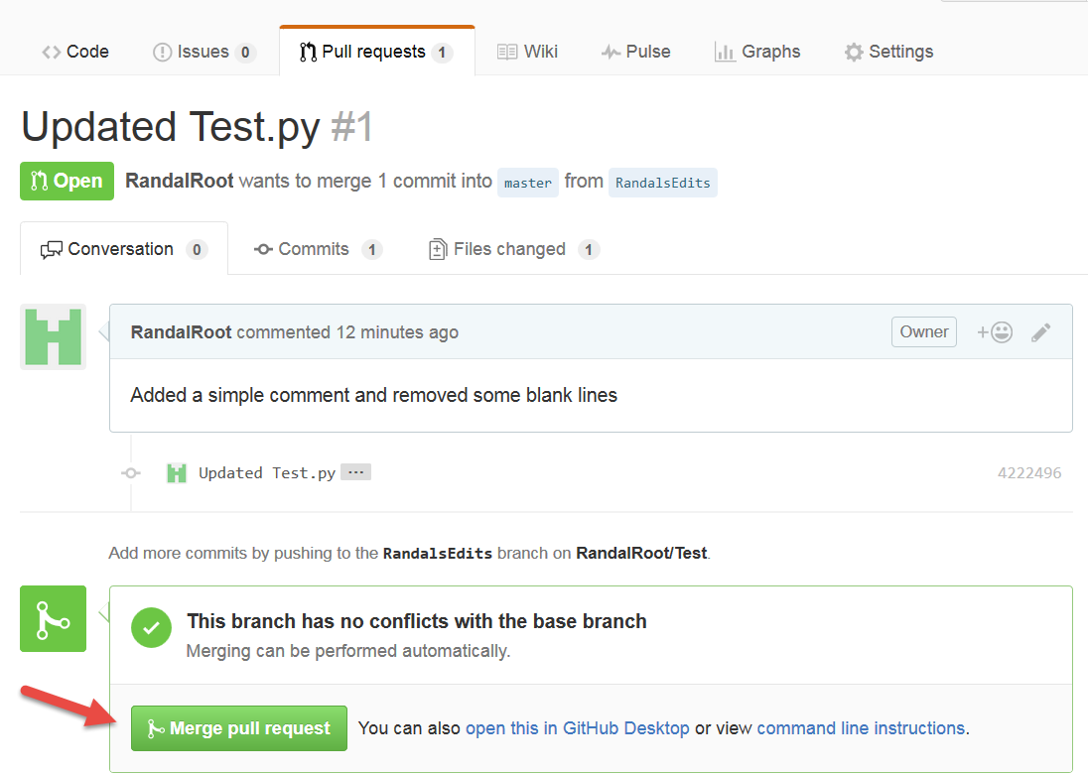

GetHub comes with a downloadable User Interface for both Windows and Mac. Once downloaded and installed, it can be launched from the dashboard or opened like any other program.

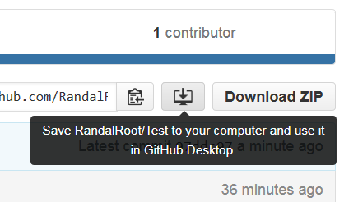

Because this software saves a copy of the files on your local computer, you need to tell it where those files will go!

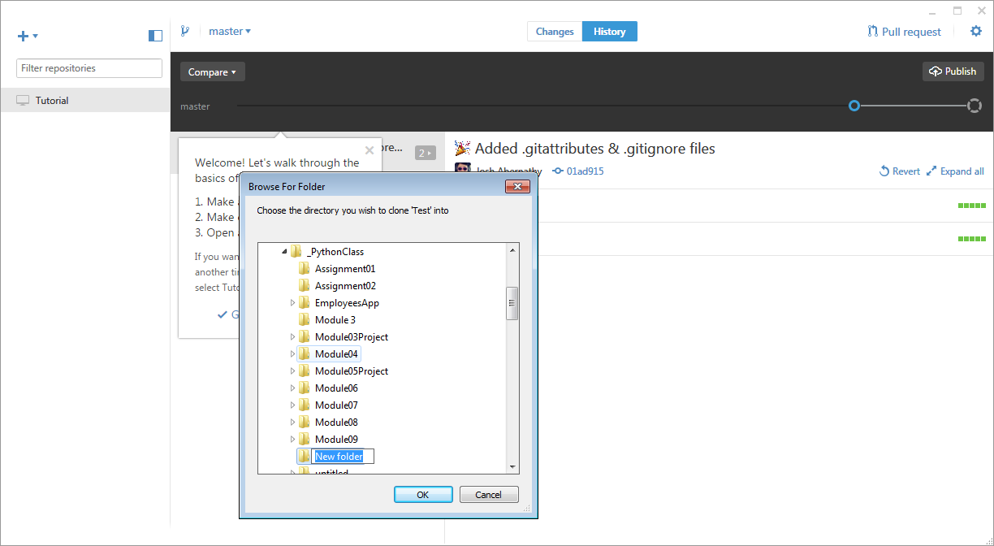

Afterwards, you will be able to manage your files using the application.

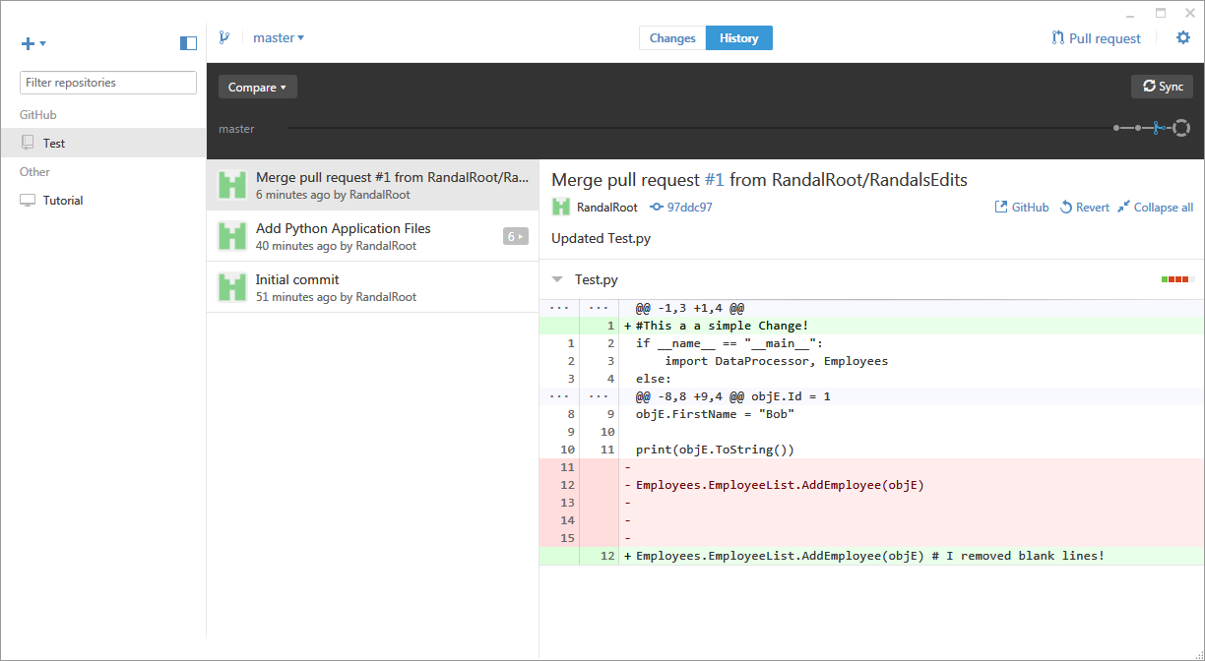

For those that would prefer using a command shell environment instead of a GUI interface you can also manage the files and repositories using the GitHub shell.

